CI CD LAB EXPERIMENT-5

(BY: AMAN TYAGI)

Aim: Jenkins integration with SonarQube

1. Start Jenkins Dashboard and Sonarqube
2. Install the Sonarqube plugin from Manage jenkins
3. Create a new maven project
4. In the config settings enter the url of the Git repo which has the project
5. Now in the build section update the path of pom.xml and enter the command

clean install sonar:sonar -Dsonar.host.url=http://localhost:9000 -Dsonar.analysis.mode=publish

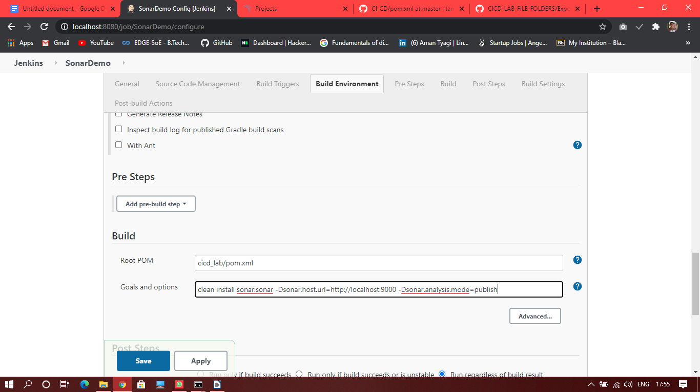

1. Build this project and see the console output

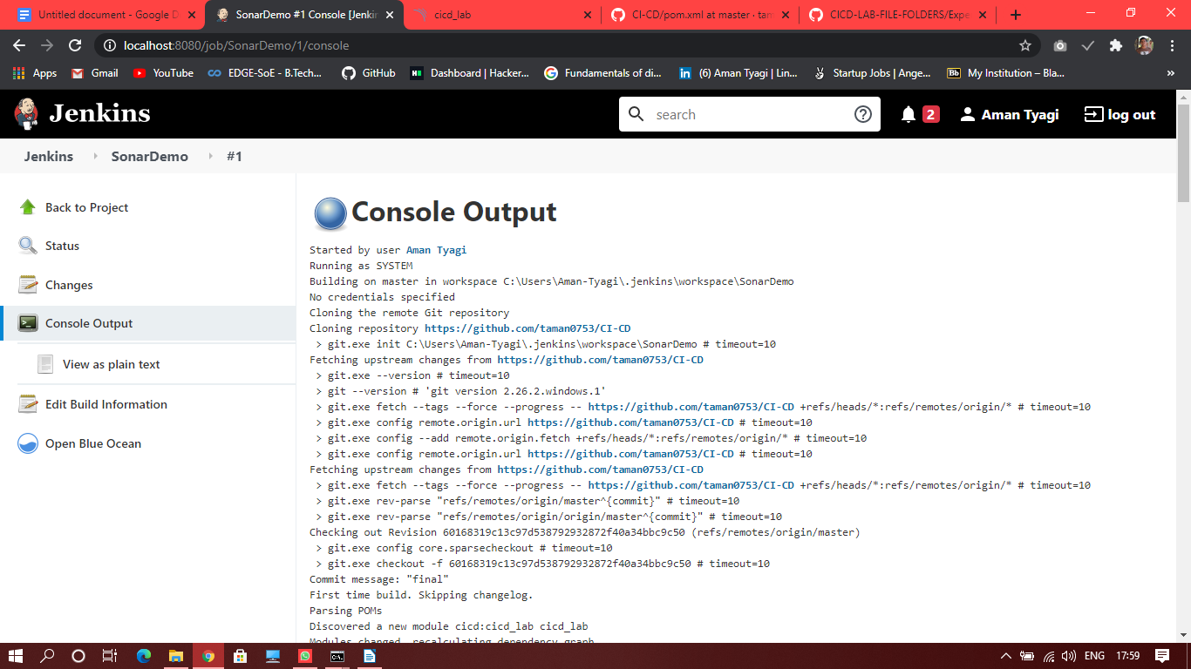

If everything is fine , it should be a build success

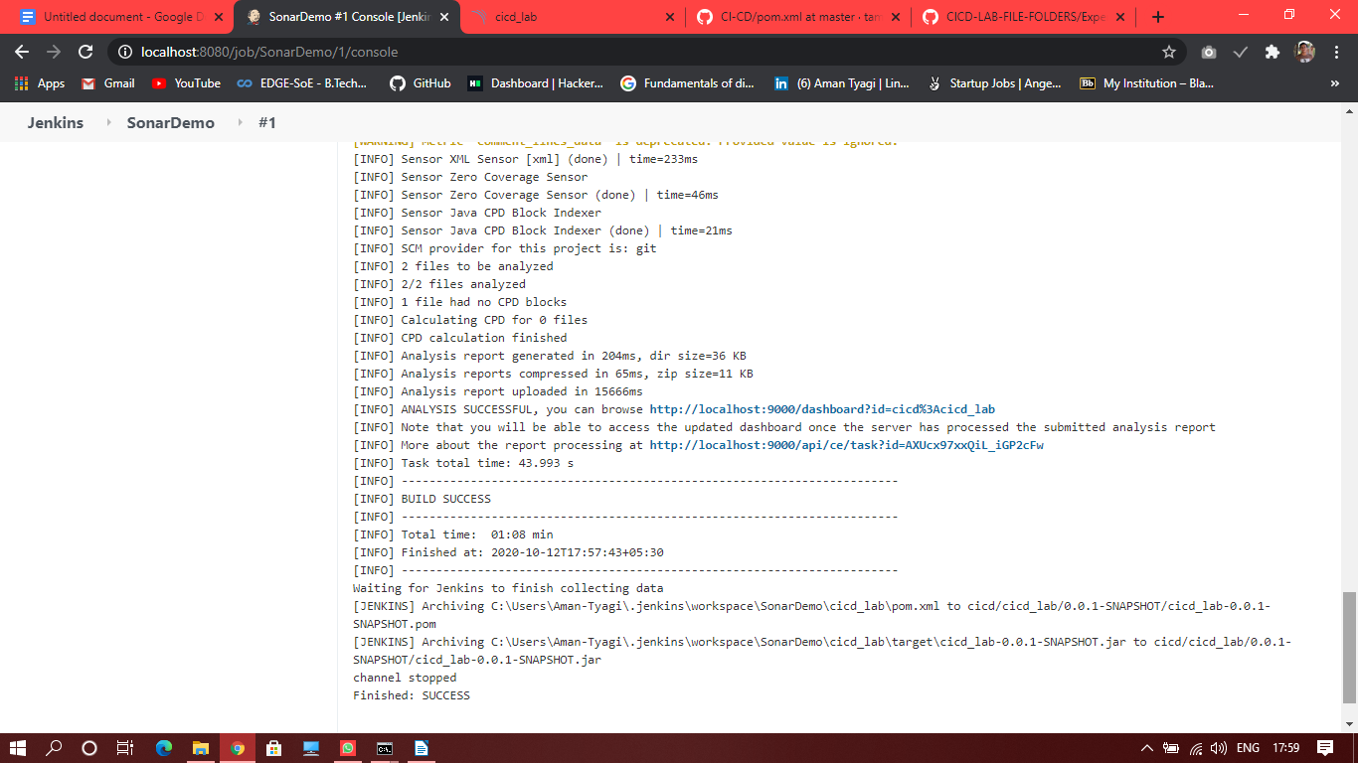

1. Refresh your sonarqube projects and you will see the project listed

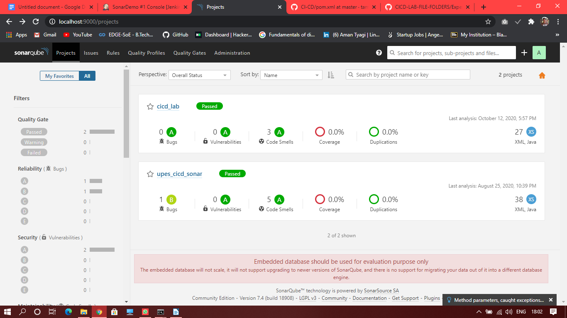

1. You can see the analysis

